Joe Griffin

Homework 3

Nov 17, 2021

Project 1

AWS online calculator setup as described in steps i, ii, and iii:

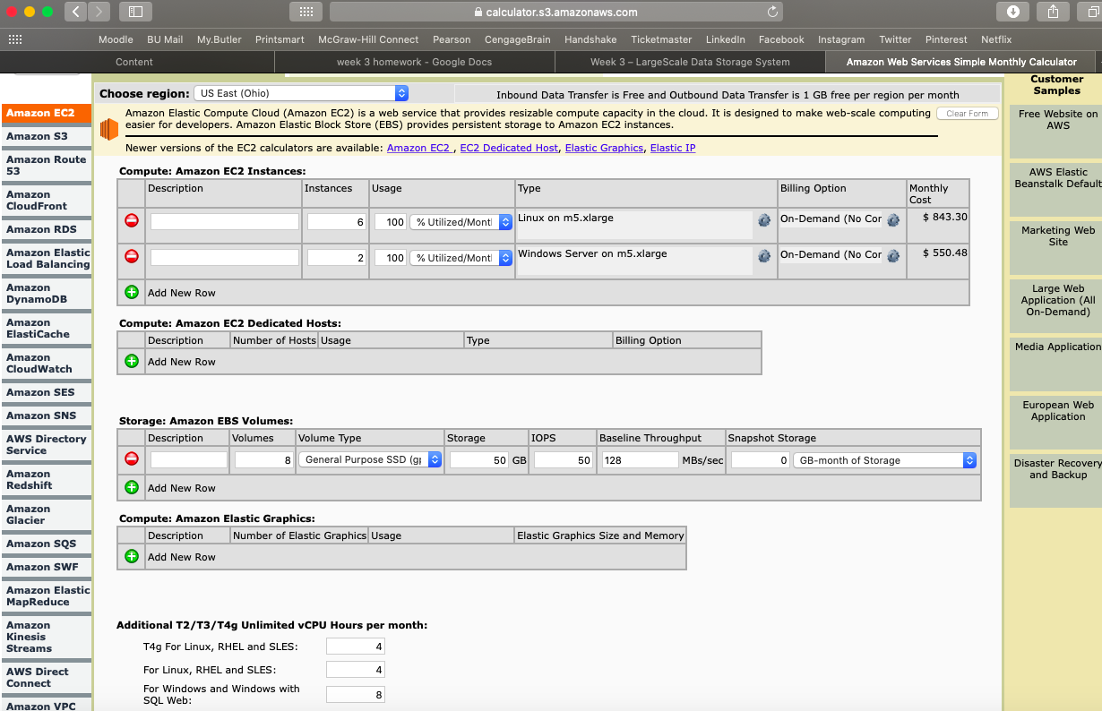

1. Price definitely varies depending on the region. I’m sure there are a number of factors that contribute to this. To compare, I added 5 instances of Linux on t3.2xlarge for 5 different regions. The results are below.

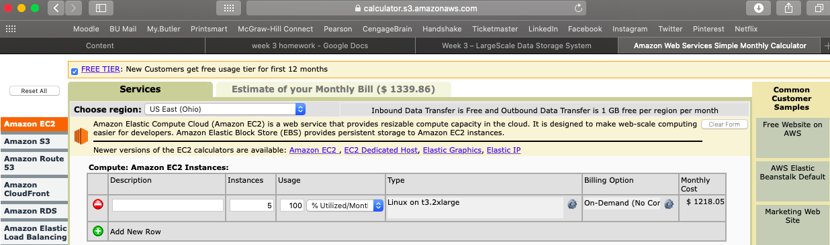

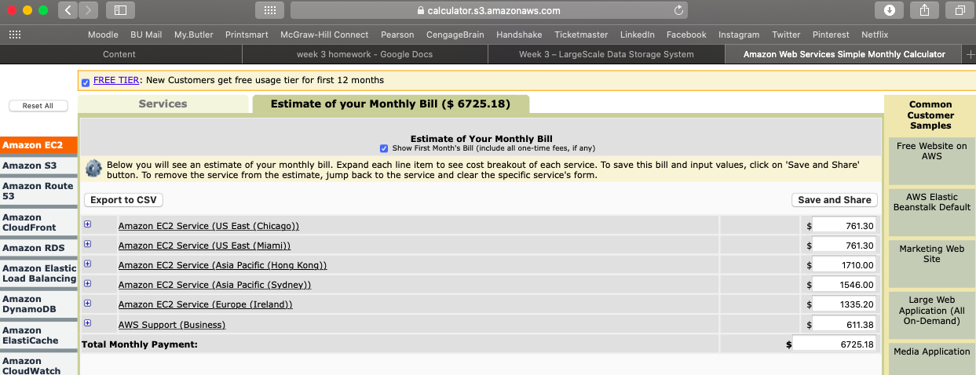

1. There is no functional difference between these two; they simply involve billing. On-demand pricing is a pay for what you use as you go system. Reserved instance allows you to commit to utilizing an instance or multiple instances for a fixed period of time. Reserved instances are also discounted, given that you are committing to business for a certain amount of time. It is also possible to pay fully or partially up front for reserved instances, further bringing down the cost. Thus, reserved instances are cheaper in theory, but if you pay for more instances that you end up needing, or if you choose a contract time that is longer than you end up needing, these costs could offset or even trump the discount of reserved instances. It makes sense for large companies to utilize reserved instances, but it may make more sense for smaller companies to utilize on-demand pricing.
2. Linux is cheaper because it’s open source.
3. u-6tb1.112xlarge had the highest CPUs (448) and the most memory (6144). It costs $54.60 per hour.

Project 2

Heroku quote:

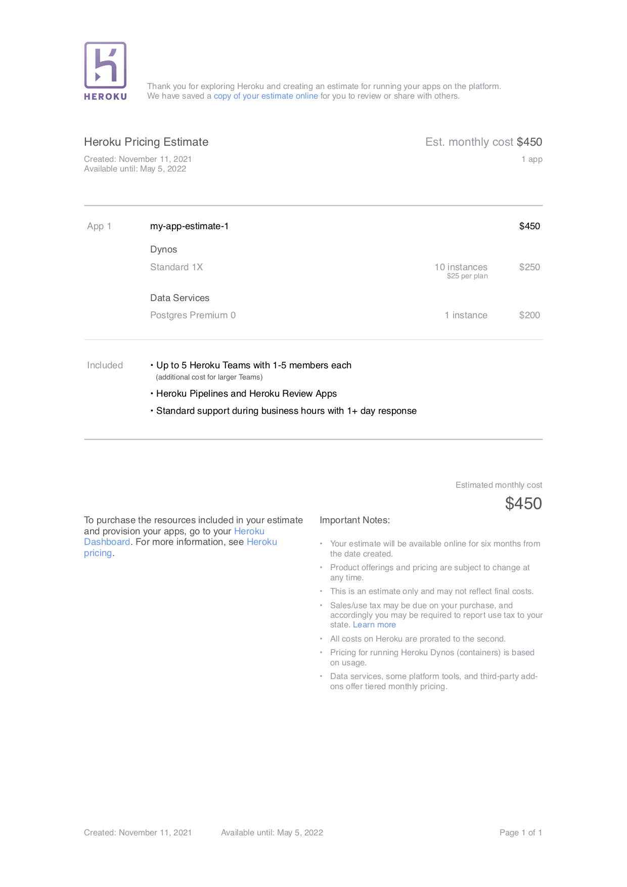

1. Dynos are isolated, virtualized Linux containers that are “the heart of the Heroku platform”. They execute code depending on the commands received from the user. A big advantage is that they are easily scalable. If there is heavy user traffic, more dynos can be employed to easily manage this. No new servers are needed in this process, just more dynos. Within an application, there are dynos that receive requests and put them into the queue. Then there are worker dynos that execute the request.

Another division of dynos is essentially their performance capability. There are free dynos, hobby dynos, and then there are four different dynos considered to be professional dynos, all with increased performance capabilities. These professional dybos have increased RAM, perform better under high traffic, have an unlimited number of process types, and also can be combined with other dyno types, among other capabilities.

Project 3

1. I would probably recommend MS Office as it is well known to many people, it is user friendly, and from my research, it appears they have the lowest price per person for large companies. However, on the other hand, for small businesses, it could be cheaper to use Shopify or Salesforce. Individual plans for MS Office are much more expensive per person than their plans for companies.

Additionally, Shopify and Salesforce offer (and I believe more) different services than MS Office. Thus, the best choice for MS Office functionality likely depends on the company and the work the functions they hope to accomplish.

1. MS Office seems to have the most simple set of options for businesses: an upfront purchase option, an “Apps for Business” option, and a “Business Standard” option. For this exercise, I am only going to look at the subscription options.

Shopify has three different options: “Basic Shopify,” “Shopify,” and “Advanced Shopify.”

Salesforce has some different options depending on the specific application, but I am going to use this set of options for this exercise: “Essentials,” “Sales Professional,” and “Service Professional.”

For all of the above options, I am calculating the per user price assuming that the maximum number of users/accounts per subscription are being utilized.

Here is a table of the calculations for 1,000 users on each of the eight plans listed above.

|  | Cost | Max # users | Per user cost | Total cost |
| --- | --- | --- | --- | --- |
| MS Office Apps for Business | 8.25 | 1 | 8.25 | 8,250 |
| MS Office Business Standard | 12.50 | 1 | 12.50 | 12,500 |
| Basic Shopify | 29 | 2 | 14.50 | 14,500 |
| Shopify | 79 | 5 | 15.80 | 15,800 |
| Advanced Shopify | 299 | 15 | 19.933333 | 19,933.33 |
| Salesforce Essentials | 25 | 1 | 25 | 25,000 |
| Salesforce Sales Professional | 75 | 1 | 75 | 75,000 |
| Salesforce Service Professional | 75 | 1 | 75 | 75,000 |